EE577 Lab4 Report

Spring 2017

Huayu Fu

4745159848

4/14/2017

# Task1 find best number of fin.

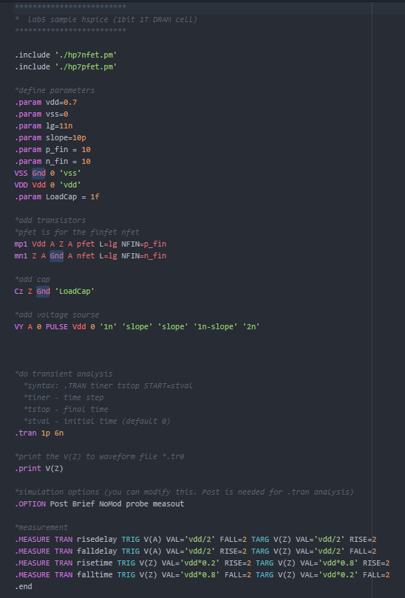

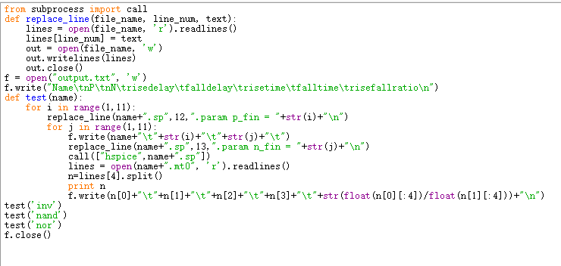

The result:

|  |  |  |  |  |  |  |  |  |
| --- | --- | --- | --- | --- | --- | --- | --- | --- |
| Name | nP | nN | risedelay | falldelay | risetime | falltime | risefallratio |  |
| inv | 7 | 6 | 2.73E-12 | 2.74E-12 | 2.75E-12 | 2.45E-12 | 0.996350365 | 0.00365 |
| inv | 8 | 7 | 2.51E-12 | 2.50E-12 | 2.40E-12 | 2.30E-12 | 1.004 | 0.004 |
| nand | 9 | 9 | 2.91E-12 | 2.92E-12 | 2.63E-12 | 2.71E-12 | 0.993150685 | 0.006849 |
| nand | 7 | 7 | 3.17E-12 | 3.20E-12 | 3.11E-12 | 2.72E-12 | 0.990595611 | 0.009404 |
| nor | 10 | 7 | 3.04E-12 | 3.07E-12 | 2.71E-12 | 3.04E-12 | 0.990196078 | 0.009804 |
| nand | 8 | 8 | 3.02E-12 | 3.07E-12 | 2.71E-12 | 2.74E-12 | 0.983660131 | 0.01634 |
| nand | 6 | 6 | 3.36E-12 | 3.43E-12 | 3.08E-12 | 2.91E-12 | 0.979591837 | 0.020408 |
| nor | 6 | 4 | 3.79E-12 | 3.70E-12 | 3.28E-12 | 3.26E-12 | 1.021621622 | 0.021622 |
|  |  |  |  |  |  |  |  |  |

The number I chose:

Inv nP=7 nN=6

Nand nP=7 nN=7

Nor nP=10 nN=7

# Task2 The delay of 2x 4x inv nand nor



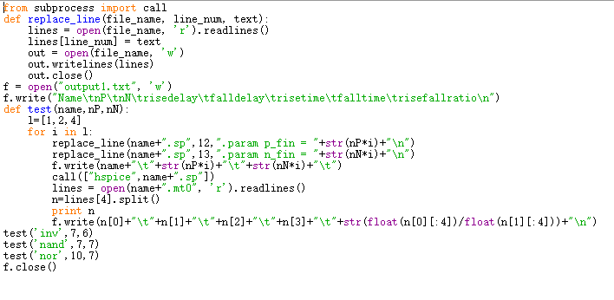

The result:

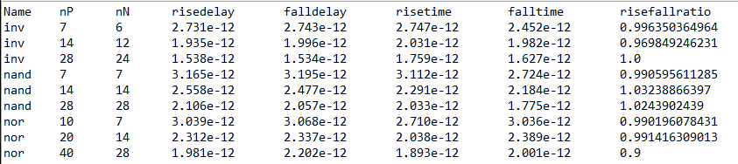

# Task3 4 mode of nand nor design.

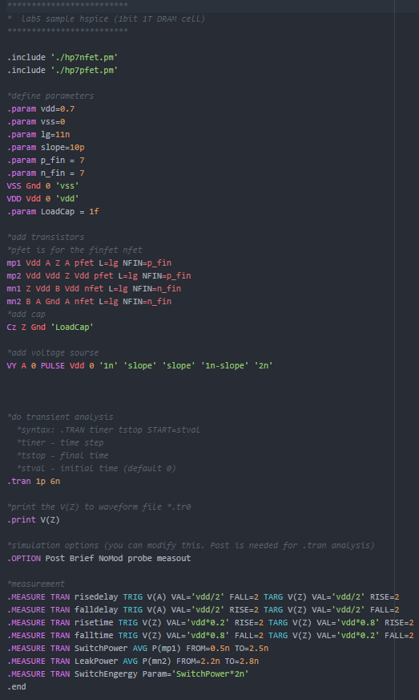

|  |  |  |  |  |  |  |  |  |
| --- | --- | --- | --- | --- | --- | --- | --- | --- |
|  |  | rise delay | fall delay | rise time | fall time | switchpower | leakpower | switchenergy |
| Nand | SG | 3.17E-12 | 3.20E-12 | 3.11E-12 | 2.72E-12 | 2.87E-07 | 5.26E-12 | 5.75E-16 |
|  | LP | 3.17E-12 | 3.24E-12 | 2.86E-12 | 2.90E-12 | 2.87E-07 | 3.73E-11 | 5.745E-16 |
|  | IG | 3.04E-12 | 3.08E-12 | 3.06E-12 | 2.63E-12 | 2.75E-07 | 1.81E-11 | 5.50E-16 |
|  | IG/LP | 3.04E-12 | 3.08E-12 | 3.06E-12 | 2.63E-12 | 2.75E-07 | 1.81E-11 | 5.50E-16 |
| Nor | SG | 3.04E-12 | 3.07E-12 | 2.71E-12 | 3.04E-12 | 3.03E-07 | 1.97E-08 | 6.06E-16 |
|  | LP | 3.00E-12 | 3.09E-12 | 2.44E-12 | 2.74E-12 | 3.03E-07 | 1.97E-08 | 6.06E-16 |
|  | IG | 2.96E-12 | 2.85E-12 | 2.59E-12 | 3.09E-12 | 2.67E-07 | 1.97E-08 | 5.33E-16 |
|  | IG/LP | 2.96E-12 | 2.85E-12 | 2.59E-12 | 3.09E-12 | 2.67E-07 | 1.97E-08 | 5.33E-16 |

# Task4 Full Adder

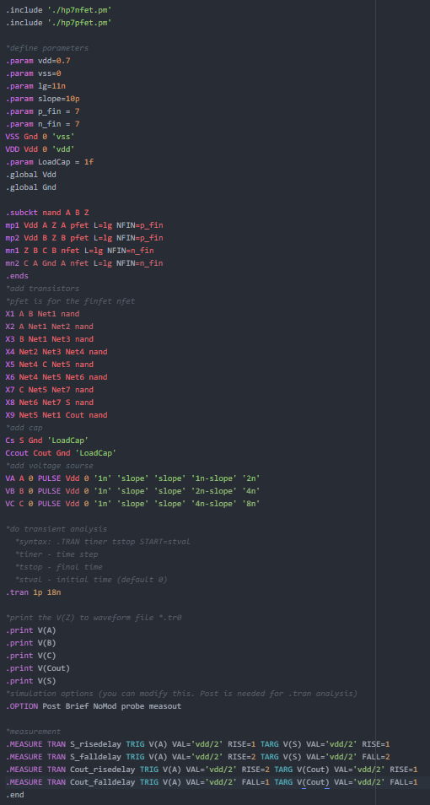

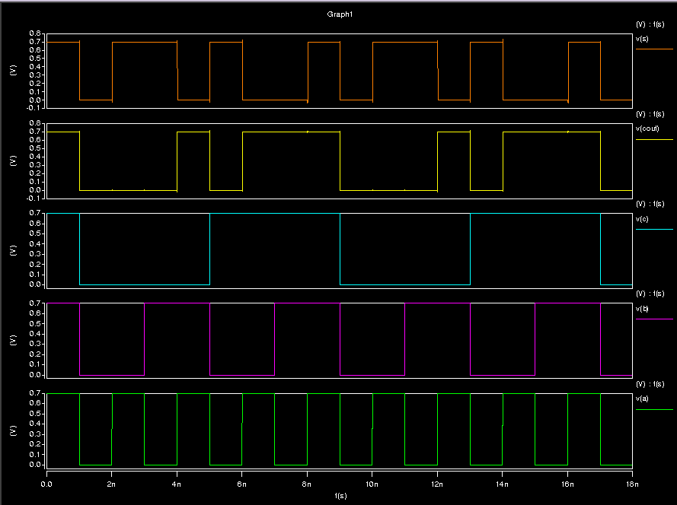

s_risedelay s_falldelay cout_risedelay cout_falldelay

8.861e-12 1.209e-11 5.912e-12 4.388e-12